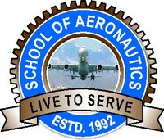
SCHOOL OF AERONAUTICS (NEEMRANA)
I 04, RIICO Industrial Area, Neemrana, Dist. Alwar, Rajasthan.

IAE-I-QUESTION PAPER

FACULTY NAME: D.SUKUMAR CLASS: B.Tech AERONAUTICAL
SUBJECT CODE: 6AN5 SEMESTER: VI
SUBJECT NAME: AIRCRAFT DESIGN

Max Marks: 30 DATE: 30/01/2019
Duration: 1Hr 45Min

Answer any four questions
(4X7.5=30 marks)

- Explain the phase Preliminary design of Aircraft Design.
- List down the Primary requirements for designing the Military Aircraft FIGHTERS-Tactical, FIGHTERS- Interceptor & Bomber.
- Explain the classification of aircraft based on the Wing configuration & fuselage configuration.
- Explain the aerodynamics consideration for designing the aircraft.
- Explain about the Structural Design Criteria (SDC) different types of load acting on the aircraft.
- With neat sketches, explain the V-n diagram.
- Write the formula for n_{max}, V_{stall} , V_{c}, Stall Speed And Minimum Speeds.
- Write down the parameters required to design the wing of an aircraft in Airplane Data Sheet.

